Python Assignment 1
SET A
Strings :-

Q1) Write a python program to check whether the string is Symmetrical or Palindrome
Ans: def check_string(s):

if s == s[::-1]:
palindrome = True
else:
palindrome = False

n = len(s)
half = n // 2

if n % 2 == 0:
first_half = s[:half]
second_half = s[half:]
else:
first_half = s[:half]
second_half = s[half+1:]

if first_half == second_half:
symmetrical = True
else:
symmetrical = False

return palindrome, symmetrical

string = input("Enter a string: ")

is_palindrome, is_symmetrical = check_string(string)

if is_palindrome:
print("The string is a Palindrome")
else:
print("The string is NOT a Palindrome")

if is_symmetrical:
print("The string is Symmetrical")
else:
print("The string is NOT Symmetrical")
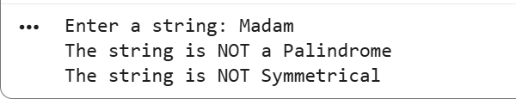
Q2) Write a Python program to reverse the words in a given string
Ans: s = input("Enter a string: ")

reversed_words = " ".join(s.split()[::-1])

print("Reversed words:", reversed_words)
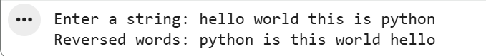
Q3) Write a Python program to remove the i’th character from the string in different ways
Ans: Method 1: Using String Slicing -
s = "pythonprogram"
i = 3

result = s[:i] + s[i+1:]
print(result)
Method 2: Using a For Loop -
s = "pythonprogram"
i = 3

result = ""
for index in range(len(s)):
if index != i:
result += s[index]

print(result)
Method 3: Using List Conversion -
s = "pythonprogram"
i = 3

lst = list(s)
del lst[i]

result = "".join(lst)
print(result)
Method 4: Using Replace() With Position Logic -
s = "pythonprogram"
i = 3

result = s.replace(s[i], "", 1)
print(result)

Functions :-
Q1) Write a python function to find the Max of three numbers
Ans: def max_of_three(a, b, c):
if a >= b and a >= c:
return a
elif b >= a and b >= c:
return b
else:
return c

num1 = int(input("Enter first integer: "))
num2 = int(input("Enter second integer: "))
num3 = int(input("Enter third integer: "))

print("The maximum number is:", max_of_three(num1, num2, num3))
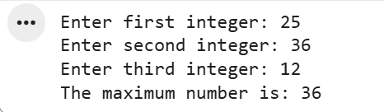
Q2) Write a python function to Sum all the numbers in a list
Ans: def list_sum(numbers):
total = 0
for num in numbers:
total += num
return total

print(list_sum([10, 20, 30, 40]))

def list_sum(numbers):
return sum(numbers)

print(list_sum([5, 15, 25]))
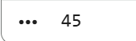
Q3) Write a Python function to reverse the string
Ans: def reverse_string(s):
return s[::-1]

print(reverse_string("Python"))

SET B

Strings :-
Q1) Write a python program to print even length words in a string
Ans: s = input("Enter a string: ")

words = s.split()

print("Even length words:")
for w in words:
if len(w) % 2 == 0:
print(w)
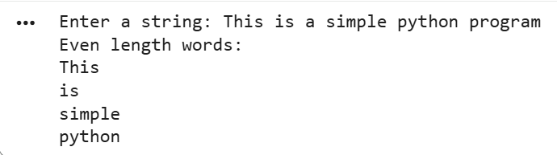
Q2) Write a python program to accept the strings which contains all vowels
Ans: s = input("Enter a string: ").lower()

vowels = set("aeiou")

if vowels.issubset(set(s)):
print("The string contains all vowels.")
else:
print("The string does NOT contain all vowels.")
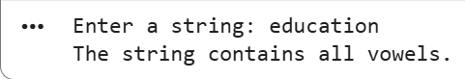
Q3) Write a python program to Count the number of matching characters in a pair of String
Ans: str1 = input("Enter first string: ")
str2 = input("Enter second string: ")

set1 = set(str1)
set2 = set(str2)

common_chars = set1.intersection(set2)

print("Matching characters:", common_chars)
print("Number of matching characters:", len(common_chars))
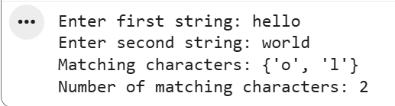
Functions :-

Q1) Write a Python function that takes a list and returns a new list with unique elements of the first list.
Ans: def unique_list(lst):
unique = []
for item in lst:
if item not in unique:
unique.append(item)
return unique

print(unique_list([1, 2, 2, 3, 4, 4, 5]))
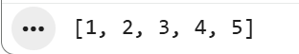
Q2) Write a python function that takes a number as a parameter and check the number is prime or not.
Ans: def is_prime(n):
if n <= 1:
return False

for i in range(2, int(n**0.5) + 1):
if n % i == 0:
return False

return True

num = int(input("Enter a number: "))

if is_prime(num):
print(num, "is a prime number")
else:
print(num, "is not a prime number")
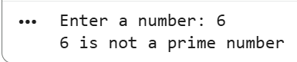
Q3) Write a python function to check whether a number is perfect or not.
Ans: def is_perfect(n):
if n < 1:
return False

total = 0
for i in range(1, n):
if n % i == 0:
total += i

return total == n

num = int(input("Enter a number: "))

if is_perfect(num):
print(num, "is a perfect number")
else:
print(num, "is not a perfect number")
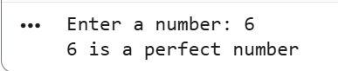
Assignment 2
SET A
1. Python Program to Calculate the Area of a Triangle
Ans: base = float(input("Enter the base of the triangle: "))
height = float(input("Enter the height of the triangle: "))

area = 0.5 * base * height

print("The area of the triangle is:", area)
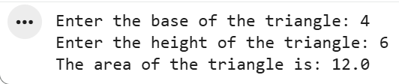
2. Python Program to Swap Two Variables
Ans: a = int(input("Enter first number: "))
b = int(input("Enter second number: "))

temp = a
a = b
b = temp

print("After swapping:")
print("a =", a)
print("b =", b)
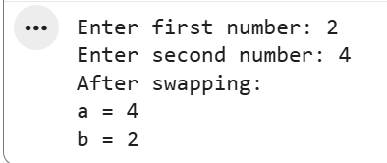
3. Python Program to Generate a Random Number
Ans: import random

num = random.randint(1, 100)
print("Random number:", num)
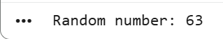
SET B
1. Write a Python Program to Check if a Number is Positive, Negative or Zero
Ans: num = int(input("Enter a number: "))

if num > 0:
print("The number is Positive.")
elif num < 0:
print("The number is Negative.")
else:
print("The number is Zero.")
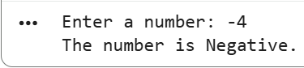
2. Write a Python Program to Check if a Number is Odd or Even
Ans: num = int(input("Enter a number: "))

if num % 2 == 0:
print("The number is Even.")
else:
print("The number is Odd.")
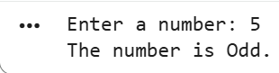
3. Write a Python Program to Check Prime Number
Ans: num = int(input("Enter a number: "))

if num > 1:
for i in range(2, int(num**0.5) + 1):
if num % i == 0:
print(num, "is NOT a prime number")
break
else:
print(num, "is a prime number")
else:
print(num, "is NOT a prime number")
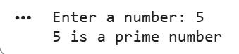
4. Write a Python Program to Check Armstrong Number
Ans: num = int(input("Enter a number: "))

digits = str(num)
power = len(digits)

total = sum(int(d)**power for d in digits)

if total == num:
print(num, "is an Armstrong number")
else:
print(num, "is NOT an Armstrong number")
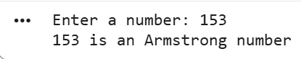
5. Write a Python Program to Find the Factorial of a Number
Ans: num = int(input("Enter a number: "))

factorial = 1

if num < 0:
print("Factorial does not exist for negative numbers.")
else:
for i in range(1, num + 1):
factorial *= i
- print("Factorial of", num, "is", factorial)
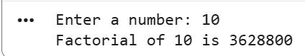
PROGRAMS FOR PRACTICE:
1. Python Program to Convert Kilometers to Miles
Ans: km = float(input("Enter value in kilometers: "))

miles = km * 0.621371

print(km, "kilometers is equal to", miles, "miles")
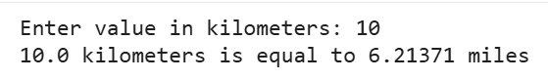
2. Python Program to Convert Celsius To Fahrenheit
Ans: celsius = float(input("Enter temperature in Celsius: "))

fahrenheit = (celsius * 9/5) + 32

print(celsius, "Celsius is equal to", fahrenheit, "Fahrenheit")
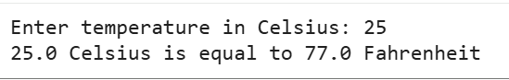
3. Write a Python Program to Check Leap Year
Ans: year = int(input("Enter a year: "))

if (year % 400 == 0) or (year % 4 == 0 and year % 100 != 0):
print(year, "is a leap year")
else:
print(year, "is not a leap year")
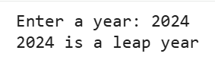
4. Write a Python Program to Print all Prime Numbers in an Interval
Ans: lower = int(input("Enter the lower range: "))
upper = int(input("Enter the upper range: "))

print("Prime numbers between", lower, "and", upper, "are:")

for num in range(lower, upper + 1):
if num > 1:
for i in range(2, int(num**0.5) + 1):
if num % i == 0:
break
else:
print(num)
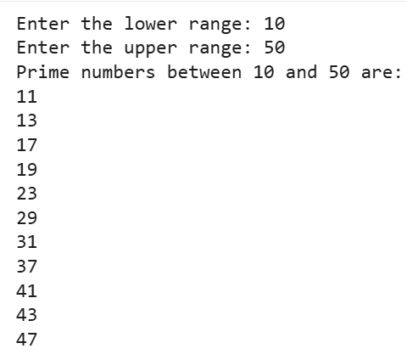
5. Write a Python Program to Print the Fibonacci sequence
Ans: n = int(input("Enter how many terms you want: "))

a, b = 0, 1

print("Fibonacci sequence:")

for _ in range(n):
print(a)
a, b = b, a + b
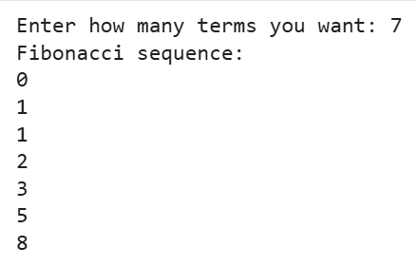
6. Write a Python Program to Find Armstrong Number in an Interval
Ans: lower = int(input("Enter the lower range: "))
upper = int(input("Enter the upper range: "))

print("Armstrong numbers between", lower, "and", upper, "are:")

for num in range(lower, upper + 1):
digits = str(num)
power = len(digits)
total = sum(int(d)**power for d in digits)

if total == num:
print(num)
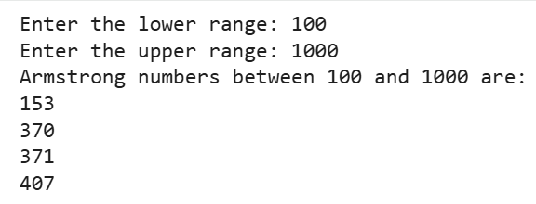
7. Write a Python Program to Find the Sum of Natural Numbers
Ans: n = int(input("Enter a positive number: "))

total = 0

for i in range(1, n + 1):
total += i

print("The sum of natural numbers up to", n, "is:", total)
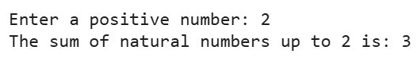
Assignment 3
1. Write a Python program to append items from a specified list
Ans: list1 = [1, 2, 3]
list2 = [4, 5, 6]

for item in list2:
list1.append(item)

print("Updated List:", list1)
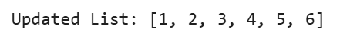
2. Write a python program Check if a Substring is Present in a Given String
Ans: string = "Hello, welcome to Python programming"
substring = "welcome"

if substring in string:
print("Substring is present.")
else:
- print("Substring is not present.")

3. Write a python program Words Frequency in String Shorthands
Ans: from collections import Counter

s = "apple banana apple orange banana apple"

freq = Counter(s.split())

print(freq)
4. Write a python program Convert Snake case to Pascal case
Ans: snake = "this_is_snake_case"

pascal = snake.replace("_", " ").title().replace(" ", "")
print(pascal)
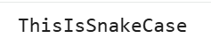
5. Write a Python function to calculate the factorial of a number (a non-negative integer). The function accepts the number as an argument.
Ans: def factorial(n):
if n < 0:
return "Factorial does not exist for negative numbers"

result = 1
for i in range(1, n + 1):
result *= i
return result
num = int(input("Enter a number: "))
print("Factorial:", factorial(num))
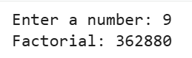
6. Write a Python function to check whether a number is in a given range
Ans: def in_range(num, start, end):
return start <= num <= end
num = int(input("Enter a number: "))
start = int(input("Enter start of range: "))
end = int(input("Enter end of range: "))

if in_range(num, start, end):
print("Number is in the given range.")
else:
print("Number is NOT in the given range.")
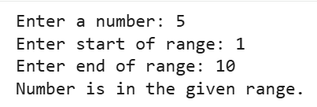
7. Write a Python function that accepts a string and calculate the number of upper case letters and lower case letters
Ans: def count_case(s):
upper = 0
lower = 0

for char in s:
if char.isupper():
upper += 1
elif char.islower():
lower += 1

return upper, lower
text = input("Enter a string: ")
u, l = count_case(text)

print("Uppercase letters:", u)
print("Lowercase letters:", l)
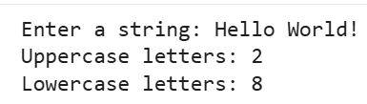
8. Write a Python program to detect the number of local variables declared in a function.
Ans: def sample_function():
a = 10
b = 20
c = a + b
name = "Python"
flag = True
print("Number of local variables:", sample_function.__code__.co_nlocals)
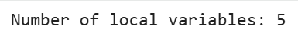
9. Write a python program to Remove all duplicates from a given string in Python
Ans: def remove_duplicates(s):
result = ""
for char in s:
if char not in result:
result += char
return result
text = "programming"
print("Original:", text)
print("After removing duplicates:", remove_duplicates(text))
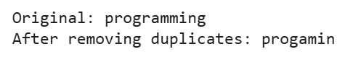
10. Write a Python function that checks whether a passed string is palindrome or not
Ans: def is_palindrome(s):
s = s.lower().replace(" ", "")
return s == s[::-1]
text = input("Enter a string: ")
if is_palindrome(text):
print("It is a palindrome.")
else:
print("It is not a palindrome.")
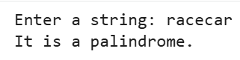
11. Write a Python program that accepts a hyphen-separated sequence of words as input and prints the words in a hyphen-separated sequence after sorting them alphabetically
Ans: words = input("Enter hyphen-separated words: ")

sorted_words = "-".join(sorted(words.split("-")))

print("Sorted sequence:", sorted_words)
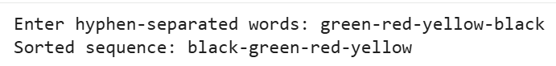
Assignment 4
SET A
List
1. Write a Python program to sum all the items in a list
Ans: numbers = [5, 8, 3, 2, 10]

total = 0
for num in numbers:
total += num

print("Sum of all items:", total)
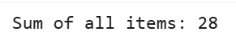
2. Write a Python program to multiplies all the items in a list
Ans: numbers = [2, 3, 4, 5]

product = 1
for num in numbers:
product *= num

print("Product of all items:", product)
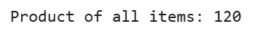
3. Write a Python program to get a list, sorted in increasing order by the last element in each tuple from a given list of non-empty tuples.
Ans: def sort_by_last(tuples_list):
return sorted(tuples_list, key=lambda x: x[-1])
data = [(2, 5), (1, 2), (4, 4), (2, 3), (9, 1)]

print("Sorted list:", sort_by_last(data))
Tuples:-
1. Write a Python program to create a tuple
Ans: my_tuple = (1, 2, 3, 4, 5)
print(my_tuple)
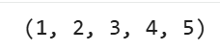
2. Write a Python program to create a tuple with different data types
Ans: mixed_tuple = (25, "Hello", 3.14, True, None, [1, 2, 3], ("a", "b"))

print("Tuple with different data types:")
print(mixed_tuple)
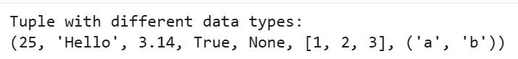
3. Write a Python program to check whether an element exists within a tuple
Ans: my_tuple = (10, 20, 30, 40, 50)

element = int(input("Enter element to check: "))

if element in my_tuple:
print("Element exists in the tuple.")
else:
print("Element does not exist in the tuple.")
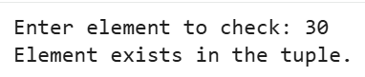
Sets:-
1. Write a Python program to create a set.
Ans: my_set = {1, 2, 3, 4, 5}
print("Set:", my_set)
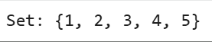
2. Write a Python program to iterate over sets
Ans: my_set = {"apple", "banana", "cherry"}

for item in my_set:
print(item)
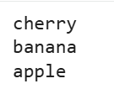
3. Write a Python program to create set difference
Ans: set1 = {1, 2, 3, 4, 5}
set2 = {4, 5, 6, 7}

diff = set1.difference(set2)

print("Difference (set1 - set2):", diff)
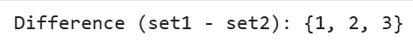
Dictionary:-
- Write a Python script to sort (ascending and descending) a dictionary by value.
Ans: my_dict = {'apple': 10, 'banana': 5, 'orange': 7, 'mango': 12}

ascending = dict(sorted(my_dict.items(), key=lambda x: x[1]))

descending = dict(sorted(my_dict.items(), key=lambda x: x[1], reverse=True))

print("Ascending:", ascending)
print("Descending:", descending)
2. Write a Python script to add a key to a dictionary
Ans: my_dict = {1: "Apple", 2: "Banana"}

# Add new key–value pair
my_dict[3] = "Cherry"

print(my_dict)
3. Write a Python program to iterate over dictionaries using for loops
Ans: my_dict = {"name": "Alice", "age": 25, "city": "Delhi"}

for key, value in my_dict.items():
print(key, ":", value)
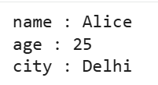
SET B
List
- Write a Python program to remove duplicates from a list
Ans: my_list = [1, 2, 2, 3, 4, 4, 5]

unique_list = []
for item in my_list:
if item not in unique_list:
unique_list.append(item)

print(unique_list)
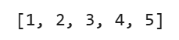
2. Write a Python program to check a list is empty or not
Ans: my_list = []

if not my_list:
print("The list is empty.")
else:
print("The list is not empty.")
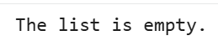
Tuples
- Write a Python program to convert a list to a tuple.
Ans: my_list = [1, 2, 3, 4, 5]

my_tuple = tuple(my_list)

print("List:", my_list)
print("Tuple:", my_tuple)
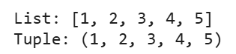
2. Write a Python program to remove an item from a tuple
Ans: my_tuple = (1, 2, 3, 4, 5)

temp_list = list(my_tuple)

temp_list.remove(3)

my_tuple = tuple(temp_list)

print("Updated tuple:", my_tuple)
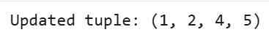
3. Write a Python program to slice a tuple
Ans: my_tuple = (10, 20, 30, 40, 50, 60, 70)

print("Tuple from index 1 to 4:", my_tuple[1:5])
print("Tuple from beginning to index 3:", my_tuple[:4])
print("Tuple from index 3 to end:", my_tuple[3:])
print("Last three elements:", my_tuple[-3:])
print("Every second element:", my_tuple[::2])
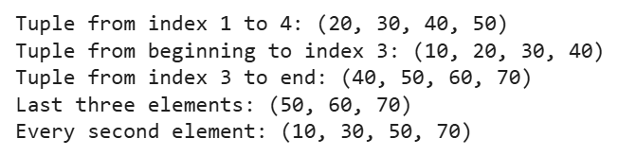
4. Write a Python program to find the length of a tuple
Ans: my_tuple = (10, 20, 30, 40, 50)

length = len(my_tuple)
print("Length of the tuple:", length)
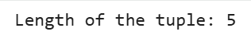
Sets
- Write a Python program to check if a set is a subset of another set.
Ans: set1 = {1, 2, 3}
set2 = {1, 2, 3, 4, 5}

# Check if set1 is a subset of set2
if set1.issubset(set2):
print("set1 is a subset of set2")
else:
print("set1 is NOT a subset of set2")
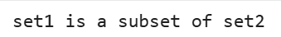
2. Write a Python program to find maximum and the minimum value in a set
Ans: numbers = {5, 8, 2, 14, 7, 3}

# Find maximum and minimum values
max_value = max(numbers)
min_value = min(numbers)

print("Maximum value:", max_value)
print("Minimum value:", min_value)
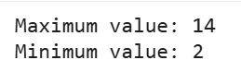
3. Write a Python program to find the length of a set.
Ans: my_set = {10, 20, 30, 40, 50}

length = len(my_set)

print("Length of the set:", length)
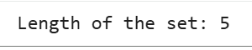
Dictionary
1. Write a Python script to generate and print a dictionary that contains a number (between 1 and n) in the form (x, x*x).
Ans: n = int(input("Enter a number: "))

result = {}

for x in range(1, n + 1):
result[x] = x * x

print(result)
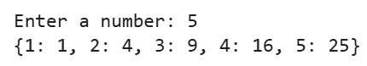
2. Write a Python script to merge two Python dictionaries.
Ans: dict1 = {'a': 1, 'b': 2}
dict2 = {'c': 3, 'd': 4}

dict1.update(dict2)

print("Merged dictionary:", dict1)

3. Write a Python program to get a dictionary from an object's fields.
Ans: class Person:
def __init__(self, name, age):
self.name = name
self.age = age

p = Person("John", 25)

result = p.__dict__

print(result)
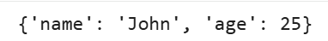
PROGRAMS FOR PRACTICE:
- Write a Python program to get the largest number from a list.
Ans: numbers = [10, 25, 4, 99, 56]

largest = max(numbers)

print("The largest number is:", largest)
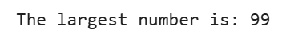
2.Write a Python program to get the smallest number from a list.
Ans: numbers = [10, 25, 4, 99, 56]

smallest = min(numbers)

print("The smallest number is:", smallest)
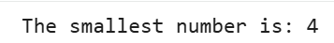
3. Write a Python program to count the number of strings where the string length is 2 or more and the first and last character are same from a given list of strings.
Ans: strings = ['abc', 'xyz', 'aba', '1221', 'bb', 'a', 'pqrp']

count = 0

for s in strings:
if len(s) >= 2 and s[0] == s[-1]:
count += 1

print("Number of valid strings:", count)
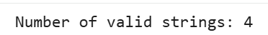
4.Write a Python program to add an item in a tuple.
Ans: my_tuple = (1, 2, 3)

item = 4

new_tuple = my_tuple + (item,)

print("Original tuple:", my_tuple)
print("New tuple:", new_tuple)
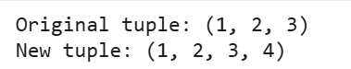

5.Write a Python program to convert a tuple to a string.
Ans: t = ('H', 'e', 'l', 'l', 'o')

result = ''.join(t)

print(result)
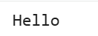

6.Write a Python program to create the colon of a tuple.
Ans: original = (10, 20, 30, 40)

clone1 = original

clone2 = tuple(original)
clone3 = original[:]

print("Original tuple:", original)
print("Clone1:", clone1)
print("Clone2:", clone2)
print("Clone3:", clone3)
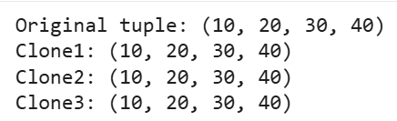

7.Write a Python program to unpack a tuple in several variables.
Ans: my_tuple = (10, 20, 30)

a, b, c = my_tuple

print("a =", a)
print("b =", b)
print("c =", c)
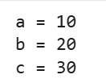

8.Write a Python program to add member(s) in a set.
Ans: my_set = {1, 2, 3}

my_set.add(4)

print("Updated set:", my_set)
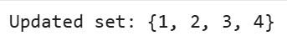

9.Write a Python program to remove item(s) from set
Ans: my_set = {1, 2, 3, 4}

my_set.remove(3)

print("Updated set:", my_set)
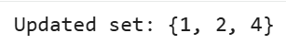

10.Write a Python program to create an intersection of sets.
Ans: set1 = {1, 2, 3, 4, 5}
set2 = {4, 5, 6, 7, 8}

result = set1.intersection(set2)

print("Intersection of sets:", result)
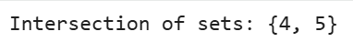

11. Write a Python program to create a union of sets.
Ans: set1 = {1, 2, 3}
set2 = {3, 4, 5}

result = set1.union(set2)

print("Union of sets:", result)
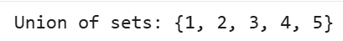
12. Write a Python script to concatenate following dictionaries to create a new one.
Ans: dict1 = {1: 10, 2: 20}
dict2 = {3: 30, 4: 40}
dict3 = {5: 50, 6: 60}

new_dict = {}

new_dict.update(dict1)
new_dict.update(dict2)
new_dict.update(dict3)

print("Concatenated dictionary:", new_dict)

13.Write a Python program to map two lists into a dictionary.
Ans: keys = ['a', 'b', 'c']
values = [1, 2, 3]

result = dict(zip(keys, values))

print("Mapped dictionary:", result)

14.Write a Python program to sort a dictionary by key.
Ans: my_dict = {3: 'apple', 1: 'banana', 2: 'cherry'}

sorted_dict = dict(sorted(my_dict.items()))

print("Sorted dictionary:", sorted_dict)

15.Write a Python program to get the maximum and minimum value in a dictionary.
Ans: my_dict = {'a': 10, 'b': 50, 'c': 5, 'd': 25}

max_value = max(my_dict.values())
min_value = min(my_dict.values())

print("Maximum value:", max_value)
print("Minimum value:", min_value)
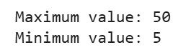

16. Write a Python program to clone or copy a list.
Ans: original_list = [1, 2, 3, 4, 5]
cloned_list = original_list[:] # Clone the list

print("Original List:", original_list)
print("Cloned List:", cloned_list)
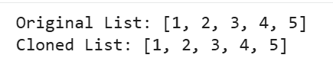

17. Write a Python program to find the list of words that are longer than n from a given list of words.
Ans: words = ["apple", "banana", "kiwi", "grapefruit", "pear", "orange"]

n = 5

long_words = [word for word in words if len(word) > n]

print("Words longer than", n, "characters:", long_words)

18.Write a Python program to unzip a list of tuples into individual lists.
Ans: data = [(1, 'a'), (2, 'b'), (3, 'c'), (4, 'd')]

numbers, letters = zip(*data)

numbers_list = list(numbers)
letters_list = list(letters)

print("Numbers:", numbers_list)
print("Letters:", letters_list)
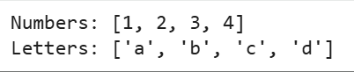

19.Write a Python program to reverse a tuple.
Ans: my_tuple = (1, 2, 3, 4, 5)

reversed_tuple = my_tuple[::-1]

print("Original tuple:", my_tuple)
print("Reversed tuple:", reversed_tuple)
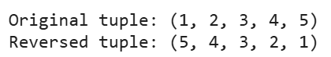

20.Write a Python program to convert a list of tuples into a dictionary.
Ans: tuple_list = [('a', 1), ('b', 2), ('c', 3)]

result = dict(tuple_list)

print("Dictionary:", result)
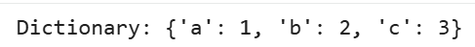

21.Write a Python program to print a tuple with string formatting.
Ans: my_tuple = (10, 20, 30)

print("Tuple values: %d, %d, %d" % my_tuple)

print("Tuple values: {}, {}, {}".format(*my_tuple))

a, b, c = my_tuple
print(f"Tuple values: {a}, {b}, {c}")
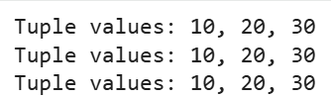

22. Write a Python program to create a symmetric difference.
Ans: set1 = {1, 2, 3, 4}
set2 = {3, 4, 5, 6}

sym_diff = set1.symmetric_difference(set2)
print("Symmetric difference:", sym_diff)

sym_diff_operator = set1 ^ set2
print("Symmetric difference using ^ operator:", sym_diff_operator)
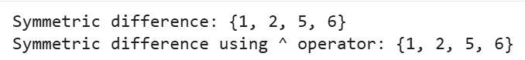

23. Write a Python program to check if a given value is present in a set or not.
Ans: my_set = {10, 20, 30, 40, 50}

value = 30

if value in my_set:
print(f"{value} is present in the set.")
else:
print(f"{value} is NOT present in the set.")
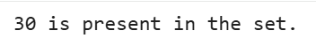

24.Write a Python program to check if a given set is superset of itself and superset of another given set.
Ans: set1 = {1, 2, 3, 4, 5}
set2 = {2, 3}

if set1.issuperset(set1):
print("set1 is a superset of itself.")
else:
print("set1 is NOT a superset of itself.")

if set1.issuperset(set2):
print("set1 is a superset of set2.")
else:
print("set1 is NOT a superset of set2.")
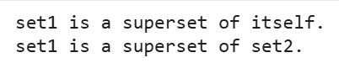
25.Write a Python program to check a given set has no elements in common with other given set.
Ans: set1 = {1, 2, 3, 4}
set2 = {5, 6, 7}
set3 = {3, 4, 5}

if set1.isdisjoint(set2):
print("set1 and set2 have no elements in common.")
else:
print("set1 and set2 have common elements.")

if set1.isdisjoint(set3):
print("set1 and set3 have no elements in common.")
else:
print("set1 and set3 have common elements.")
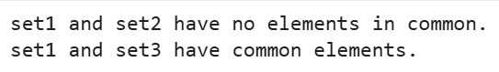

26.Write a Python program to remove the intersection of a 2nd set from the 1st set.
Ans: set1 = {1, 2, 3, 4, 5}
set2 = {3, 4, 6}

set1.difference_update(set2)

print("Set after removing intersection:", set1)

27. Write a Python program to remove duplicates from Dictionary.
Ans: my_dict = {'a': 1, 'b': 2, 'c': 1, 'd': 3, 'e': 2}

new_dict = {}
for key, value in my_dict.items():
if value not in new_dict.values():
new_dict[key] = value

print("Dictionary without duplicates:", new_dict)
28. Write a Python script to check whether a given key already exists in a dictionary.
Ans: my_dict = {'name': 'Alice', 'age': 25, 'city': 'Delhi'}

key_to_check = 'age'

if key_to_check in my_dict:
print(f"Key '{key_to_check}' exists in the dictionary.")
else:
print(f"Key '{key_to_check}' does NOT exist in the dictionary.")

29.Write a Python program to sum all the items in a dictionary.
Ans: my_dict = {'a': 100, 'b': 200, 'c': 300}

total = sum(my_dict.values())

print("Sum of all items in the dictionary:", total)

30.Write a Python program to multiply all the items in a dictionary.
Ans: my_dict = {'a': 2, 'b': 3, 'c': 4}

result = 1

for value in my_dict.values():
result *= value

print("Multiplication of all items in the dictionary:", result)

31.Write a Python program to remove a key from a dictionary.
Ans: my_dict = {'name': 'Alice', 'age': 25, 'city': 'Delhi'}

key_to_remove = 'age'

removed_value = my_dict.pop(key_to_remove, None)

print("Updated dictionary:", my_dict)
print("Removed value:", removed_value)
